Play 2: Age 3-6

Daphne O. Pack
Department of Home and Family, Brigham Young University-Idaho
CHILD310: Early and Middle Child Development
Brother Rowe
Nov. 17, 2025

For this assignment, I made and decorated sugar cookies with Aubrey, Bekah, and Phebe from class. We gathered at Aubrey’s apartment and, using a recipe online, we measured and mixed up the cookie dough and made the buttercream frosting. Once the cookies were finished baking, we used the frosting to decorate them. We wanted to use different colors but the only dye we had was green, so we just made different shades of green frosting.
This activity was inspired by the daily activity recommendation for five-year-olds that reads, “Plan cooking experiences that involve children: washing and peeling vegetables; cutting out cookies; measuring, mixing, and stirring.” (Marotz, 2023). This was a great form of play because it was pleasurable, intrinsically motivated, and actively engaged.
According to Marotz (2023), the typical five-year-old should have a general control of fine and gross motor skills, and “established hand dominance for the most part.” Baking and decorating cookies requires a lot of fine motor skills and tool manipulation including stirring with a spoon or whisk, using cookie cutters to make shapes, rolling and kneading dough, and spreading frosting. For perceptual-cognitive development, making cookies is the perfect opportunity to practice following multiple step directions, learning the concept of time (how long it takes to bake), and understanding the concept of ‘half’ when halving the dough. This is also a great activity to develop social-emotional skills like following adult instructions and working cooperatively with others.
While playing I felt content and like I was able to step away from my worries and just have wholesome, creative fun. After playing I felt calmer and was better able to focus on my homework. It strengthened my friendship with my classmates because we got to chat, collaborate on a project, and problem solve together. For busy students, making time for play sounds a little daunting and unnecessary, but I experienced how beneficial it is. I can incorporate play better into my life by not taking everything so seriously. Sometimes it’s okay to just let go and be silly. I can take frequent breaks to engage in an activity that is physically or mentally stimulating just for the fun of it.
While getting together to make cookies was a perfect activity for college students, it can easily be adapted to include a five-year-old. We discussed the importance of letting the child have hands-on experience and get messy. It’s important for a child to try something new and feel proud when they accomplish it. As adults we can scaffold their cookie-making experience by providing child appropriate tools (child-sized whisks, spoons, rolling pins, butter knives, etc.), pre-measuring ingredients or helping them count scoops, and of course, giving the child free reign over the cookie cutting and decorating. Another way we could adapt this activity would be to add music, friends, or game elements to make it more exciting.
The more I learn about children and reflect on my personal play experiences, the more I think about ways to involve my future children in my everyday life. To a child, everything about the world is new and exciting. I think something I will do is treat mundane tasks like a new adventure for my child and involve them based on their interest and developmental capabilities. For example, involving them in cooking, cleaning dishes, folding laundry, grocery shopping, going on walks, watering plants, etc.
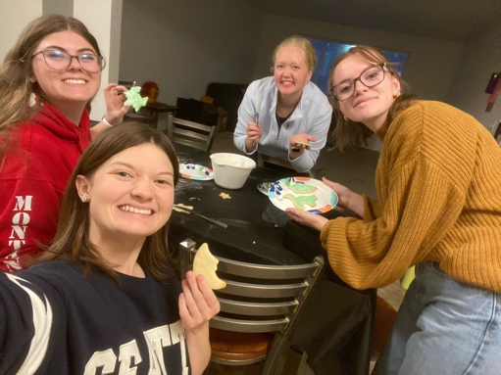

References
Marotz, L. R. (2023). Developmental profiles: Pre-birth through adolescence. 9, 156-162.

